DAR ES SALAAM INSTITUTE OF TECHNOLOGY

BACHELOR OF ENGINEERING IN COMPUTER ENGINEERING - NTA L7
ANALOGUE ELECTRONICS GROUP WORK GROUP MEMBERS:
SN | NAME | REGISTRATION NO
1 | ISMAIL MBAROUK SAID | 240242483521
2 | DEBORA BRYSON LEMA | 240242455798
3 | SALVATORY KILIMANJARO JAPHET | 240242403723
4 | FAHYIM HAMAD MASOUD | 240242495125
5 | TASIANA VITUS MLWALE | 240242412104
6 | FARAJA ANDROPH WILSON | 240242477818
7 | MUKTARI ABUBAKARI OMARY | 240242455491
8 | SIXBERTH SWEETBERTH MUGISHA | 240242405959
9 | ABUBAKAR HAMAD MSUMAI | 240242467561
10 | ESSAU JOSEPH QAMARA | 240242415115

Capacitors
A capacitor is a passive electrical component that stores electrical energy in an electric field between two conductive plates separated by an insulating material called a dielectric.
- Construction: Typically consists of two parallel conductors (plates) separated by a dielectric (e.g., air, ceramic, paper, or electrolyte).
- Principle of Operation: When a voltage (V) is applied across the terminals, charge (Q) accumulates on the plates (positive on one, negative on the other), creating an electric field in the dielectric.
- Capacitance (C): The measure of a capacitor's ability to store charge. It is defined as the ratio of the maximum charge (Q) that can be stored to the applied voltage (V): C = Q / V
- Unit: The SI unit for capacitance is the Farad (F).
- Behavior: A capacitor opposes changes in voltage. In a DC circuit, it acts like an open circuit in the steady state (fully charged). In an AC circuit, it allows current to appear to flow, with its opposition to AC flow (capacitive reactance) decreasing with frequency.
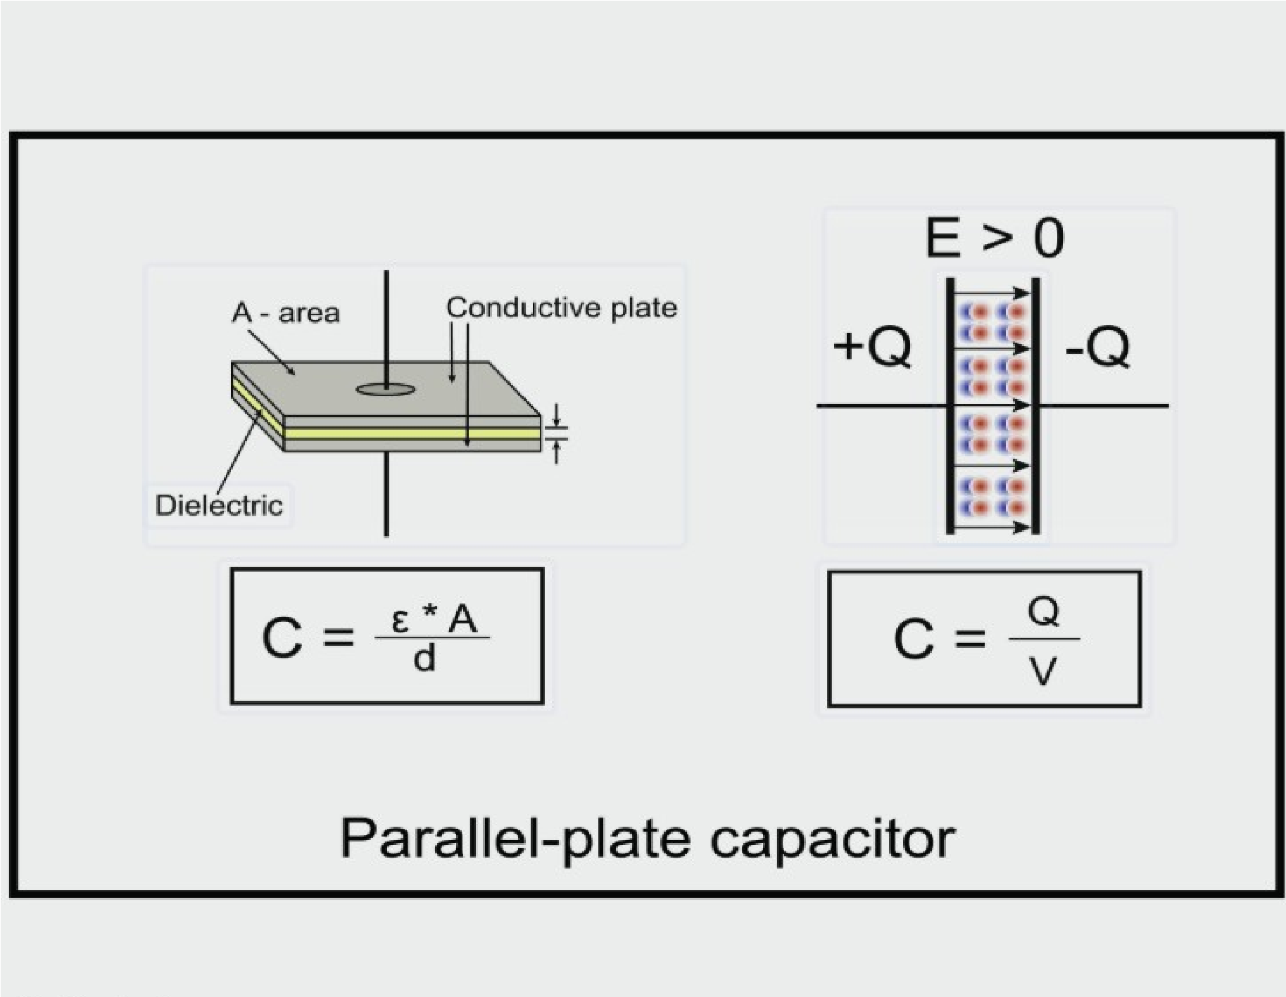

Overview
This visualization explains the concept of a parallel-plate capacitor, a fundamental electronic component used to store electrical energy in an electric field. The diagram illustrates its physical structure, the electric field behavior within it, and the mathematical formulas that govern its capacitance. A parallel-plate capacitor consists of two parallel conductive plates separated by a dielectric material.

Physical Structure
The first part of the diagram showcases the physical construction of a parallel-plate capacitor. It highlights the two conductive plates, which are typically made of metal. These plates have a specific area, denoted as 'A', and are separated by a small distance, 'd'.

Dielectric Material
Sandwiched between the conductive plates is a dielectric material. This is an electrical insulator that can be polarized by an applied electric field. The presence of a dielectric increases the capacitor's ability to store charge.

Geometric Capacitance Formula
Below the physical model is the formula for capacitance based on the capacitor's geometry.
Capacitance (C) is directly proportional to the permittivity of the dielectric material (ε) and the area of the plates (A), and inversely proportional to the distance between the plates (d). This formula is useful for designing capacitors with specific capacitance values.

Electric Field And Charge
The second part of the diagram illustrates what happens when a voltage is applied across the capacitor. The plates accumulate equal and opposite charges, with one plate having a positive charge (+Q) and the other a negative charge (-Q). This charge separation creates a uniform electric field (E) between the plates, directed from the positive to the negative plate.

Polarization Of The Dielectric
Within the electric field, the molecules of the dielectric material become polarized. The small red and blue circles represent the alignment of dipoles within the dielectric, which opposes the external electric field. This polarization effect is what allows the capacitor to store more charge for a given voltage.

Electrical Capacitance Formula
Finally, the diagram presents the fundamental definition of capacitance in electrical terms. Capacitance (C) is defined as the ratio of the magnitude of the charge (Q) on one of the plates to the potential difference or voltage (V) across the plates. This formula highlights the relationship between charge, voltage, and capacitance in a functioning capacitor.

Principle of Operation
When a voltage is applied across the plates, an electric charge (Q) accumulates on the plates. One plate stores a positive charge, and the other stores an equal but opposite negative charge. The presence of the dielectric allows the component to store more charge for a given voltage.
Capacitance:
This is the measure of a capacitor's ability to store charge. It is defined as the ratio of the magnitude of the charge (Q) on either plate to the magnitude of the voltage (V) applied across it.
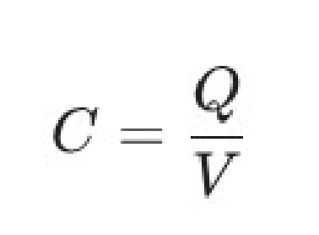
The SI unit for capacitance is the Farad (F). A capacitor has a capacitance of one farad if one coulomb of charge is stored when one volt is applied across it.

Parallel Analysis
In a parallel connection, the voltage across each capacitor is the same, but the total charge is the sum of the charges on individual capacitors.
Equivalent Capacitance:
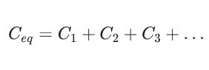

Series Analysis
In a series connection, the charge stored on each capacitor is the same, but the total voltage is the sum of the voltages across individual capacitors.
Equivalent Capacitance:
The reciprocals of the individual capacitances add up, similar to resistors in parallel.
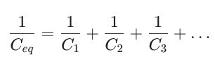

Power and Energy in Capacitors

Energy Storage
The energy (W) stored in a capacitor is held in the electric field between the plates. This energy is given by:
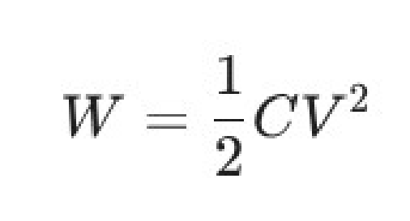
where W is in Joules (J), C is in Farads (F), and V is in Volts (V).

Power
The instantaneous power (p) supplied to a capacitor is the product of the instantaneous voltage (v) across it and the instantaneous current (i) flowing through it.
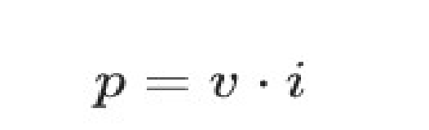
Since the current in a capacitor is I = C x dv / dt, the power can also be expressed as:
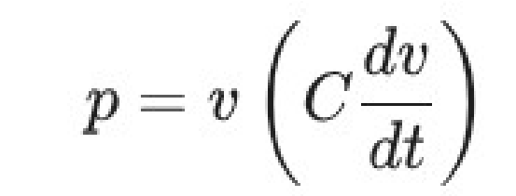
The capacitor is a purely reactive component, meaning that it only stores and returns energy, and ideally dissipates no power.

Applications of Capacitors
- Filtering and Smoothing: They are crucial in DC power supplies to smooth out the rectified AC signal (ripple removal).
- Timing: Used in combination with resistors (RC circuits) to set time delays and control the frequency of electronic oscillators.
- Coupling/Decoupling: Used to block DC signals while allowing AC signals to pass (AC coupling) or to bypass unwanted high-frequency noise to ground (decoupling).
- Energy Storage: Used in camera flashes, defibrillators, and uninterruptible power supplies (UPS) for releasing a large amount of energy quickly.

Main Categories of Capacitors
Capacitors are generally classified into two major groups:

1. Fixed Capacitors
These are the most common type and have a fixed, unchanging capacitance value.
Examples of fixed capacitor
i. Ceramic Capacitors ii. Electrolytic Capacitors (Aluminum) iii. Tantalum Capacitors iv. Film Capacitors
v. Mica Capacitors vi. Supercapacitors (or Ultracapacitors)
2. Variable Capacitors:
These capacitors are designed to have an adjustable capacitance value. They are typically used in tuning circuits, like in older radios
Examples of variable capacitors
i. Tuning Capacitors (Air Variable) ii. Trimmer Capacitors iii. Vacuum Variable Capacitors

Inductors
An inductor (or coil) is a passive two-terminal electrical component used to store electrical energy in a magnetic field when electric current flows through it.
Structure: It typically consists of a coil of wire wound around a core (which can be air, iron, or ferrite).
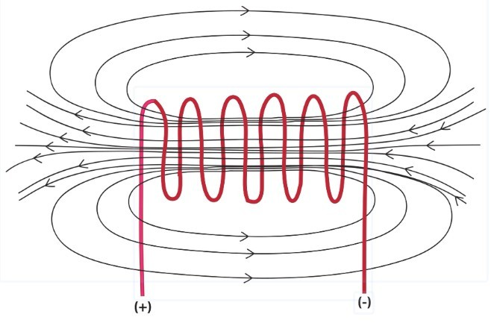

Overview
The image is a two-dimensional visualization of the magnetic field of a solenoid. A solenoid is an inductor, which is a coiled wire through which an electric current passes, generating a magnetic field in the process. This magnetic field is illustrated with black lines and arrows around a red coiled wire.

Solenoid
The red coil is a solenoid, which is a type of inductor that creates a magnetic field when electricity flows through it. The direction of the current in the wire determines the polarity of the magnetic field. This phenomenon is described by Ampere's Law, which states that a current-carrying wire produces a magnetic field.

Electrical Terminals
The plus and minus signs at the ends of the wire indicate the direction of current flow, which is from the positive to the negative terminal. This creates a current that flows in a specific direction, which is what generates the magnetic field. The direction of the current determines the north and south poles of the magnetic field.

Magnetic Field
The magnetic field lines, shown in black, illustrate the direction and strength of the magnetic field created by the solenoid. The arrows on the lines indicate the direction of the field, and the density of the lines represents the strength of the field. Inside the solenoid, the magnetic field is strong and uniform, which makes it useful in a variety of applications, such as transformers and electromagnets.
Principle of Operation: When current ($i$) flows through the coil, a magnetic flux (\phi) is generated, linking the turns of the coil. According to Faraday's Law of Induction, a changing magnetic flux induces a voltage (or electromotive force, EMF) across the inductor, opposing the change in current.
Inductance (L): This is the measure of an inductor's ability to resist changes in electric current. It is defined as the ratio of the magnetic flux linkage (N\phi) to the current (i):
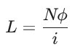
The SI unit for inductance is the Henry (H). An inductor has an inductance of one henry if a current changing at one ampere per second results in an induced voltage of one volt.
Series Analysis
In a series connection, the current through each inductor is the same, and the total voltage is the sum of the individual voltages. Assuming no mutual inductance (magnetic coupling) between the coils:
Equivalent Inductance : Inductors in series add up, similar to resistors in series.
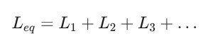

Parallel Analysis
In a parallel connection, the voltage across each inductor is the same, but the total current is the sum of the individual currents. Assuming no mutual inductance:
• Equivalent Inductance : The reciprocals of the individual inductances add up, similar to resistors in parallel.
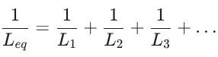

Power and Energy in Inductors Energy Storage
The energy (W) stored in an inductor is held in the magnetic field created by the current. This energy is given by:

where W is in Joules (J), L is in Henries (H), and I is in Amperes (A).

Power
The instantaneous power (p) supplied to an inductor is the product of the instantaneous voltage ($v$) across it and the instantaneous current (i) flowing through it.
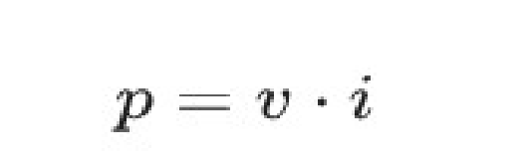
Since the voltage across an inductor is V = L x di / dt, the power can also be expressed as:
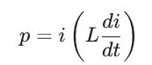
Similar to the capacitor, the ideal inductor is a purely reactive component, meaning it stores and returns energy and ideally dissipates no power.

Applications of Inductors
Inductors have various applications, particularly in AC circuits and power electronics:
- Filters: Used with capacitors (LC filters) to select or reject specific frequencies (e.g., in radio tuning circuits).
- Chokes: Used to block AC while allowing DC to pass, essential for noise suppression in power supplies.
- Transformers: Form the basis of transformers, which use mutual inductance between two coils to step up or step down AC voltage.
- Energy Storage in DC/DC Converters: Crucial components in switching regulators (e.g., Buck, Boost converters) where they store and release energy to change voltage levels efficiently.

Main categories of inductors
They are primarily categorized by the core material they use and their physical/functional design.

1. Inductor Categories by Core Material
The core material determines the inductor's magnetic properties and frequency limitations. Types of Inductor Categories by Core Material i. Non-Magnetic Core
Examples: Air-Core Inductors, Ceramic-Core Inductors. ii. Ferromagnetic Core (High Permeability)
Examples: Iron-Core Inductors (or Laminated Steel-Core), Ferrite-Core Inductors, Powdered-IronCore Inductors.
2. Inductor Categories by Physical/Functional Design
These categories are based on the inductor's shape, construction, or primary circuit function. Types of Inductor Categories by by Physical/Functional Design i. Winding/Shape
Examples: Toroidal Inductors (doughnut shape), Drum/Bobbin Core Inductors, Axial Inductors (like a resistor with color codes).
- Circuit Function
Examples: Choke Inductors (e.g., RF Chokes, Common Mode Chokes), Power Inductors, Coupled Inductors (two coils on a single core, like a transformer).
- Mounting/Construction
Examples: Surface Mount Device (SMD) Inductors, Multi-Layer Chip Inductors, Thin-Film Inductors.
- Adjustability
Examples: Fixed Inductors, Variable Inductors (adjustable by moving a core slug).

